W-12
YEAR 10 SCIENCE
BIOLOGICAL SCIENCE
GENETICS REVISION - TEST 1

1. Label the following simple cell drawing. For each part, label its main function. Choose from the
following names - not all parts are shown in the diagram.

Nucleus Cell Membrane Cell Wall Nucleolus Ribosome Mitochondria
Endoplasmic Reticulum Golgi Complex Vesicles Centrioles

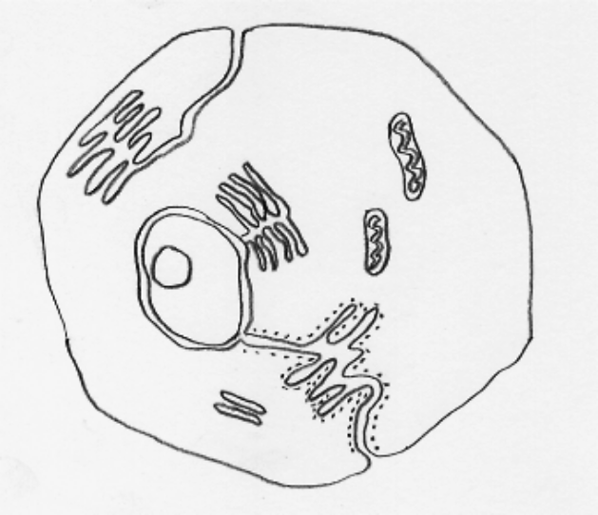

2. (a) Give a brief description of the DNA molecule.
(b) Name the 4 bases in a DNA molecule.
(c) Name the base pairs found in DNA.
(d) Draw the adjoining strand of DNA for the following.

- G - T - T - A - C - A - G - T

3. (a) Which process of cell division is responsible for the growth and repair of cells?
(b) Which process is involved in producing the reproductive cells of an animal?
(c) What is the meaning of haploid and diploid number?

4. An organism has 4 chromosomes in its normal body cells. Draw a series of simple diagrams showing
the stages involved in mitosis. Name each stage and state what is happening in each.

5. OPTIONAL
Meiosis occurs in reproductive organs in two stages. Draw a series of diagrams to show the stages
involved. Name each stage and state what is happening in each.

